**Experimental Method (Supplementary)**

Samples were prepared by taking an equimolar mix of the C3-C10 and C12 straight chain dicarboxylic acids (sourced from Sigma Aldrich with purities of 99% or higher) and heating the mixture until the highest melting point diacid (C12) had dissolved into the resultant liquid. Subsequent reheating of the sample illustrated a homogenous solid solution where all components simultaneously became liquid at 80 C, a lower melting point that any of the individual acids. Subsequent heating and cooling had no further effect on the mixture as confirmed by repeated DSC measurements. For measurements at different water mole fractions, water was measured out volumetricly using a syringe and was mixed in with the diacids using the same heat-cool cycle in a sealed container.

Viscosity measurements we made using a TA Instruments DH-1 rheometer operating in oscillation mode. The system consists of an upper and lower plate, the upper plate is mechanically controlled to monitor displacement, lateral force and torque (see Figure 1). The lower plate has a peltier element for precise temperature control. The upper plate is lowered onto the sample, the sample is then heated to a liquid (80-90 C) to ensure there are no gaps and the entire plate area is covered, the distance between the plates is 1500 µm.

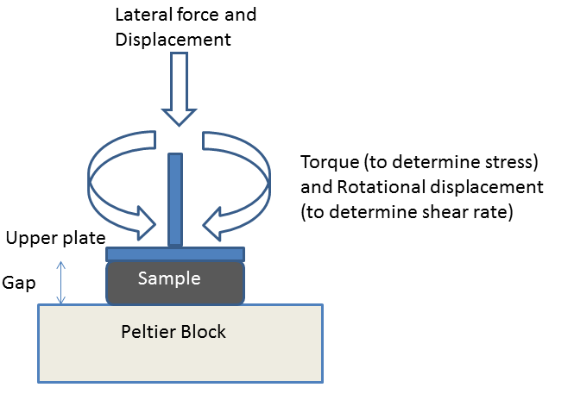

Figure Schematic of Rheometer

Oscillation mode consists of the upper plate being moved sinusoidally back and forth over a very narrow displacement. Sinusoidally oscillating shear strain (γ) produces a stress (τ) phase shifted by an angle (δ) (See Figure 2). The stress wave can be broken into two waves, in phase and out of phase (90) with respect to the strain wave.

$$τ=τ´+τ´´={τ´}_{0}sinωt+{τ´´}_{0}cosωt$$

The in phase or elastic modulus G’ and the out of phase, viscous or loss modulus G’’ come from

$$G^{'}=\frac{{τ'}_{0}}{γ_{0}}$$

And

$$G^{''}=\frac{{τ''}_{0}}{γ_{0}}$$

the dynamic viscosity can then be calculated from

$$η=\frac{G''}{ω}$$

where ω is the angular frequency of the plate.

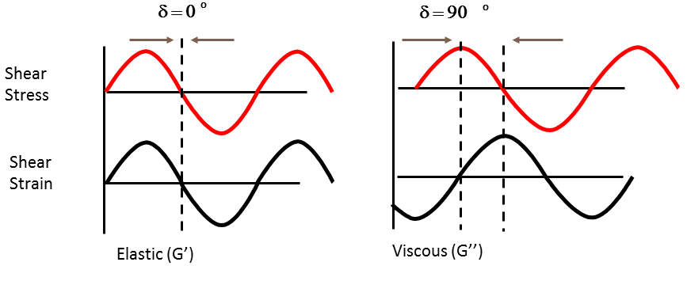

Figure In phase and out of phase shear strain response to a shear stress

For our oscillation experiments we chose a small displacement of 1e-4 radians based on experience with polymer melt samples and an oscillation frequency of 1 Hz. Heating and cooling temperature ramps were from -5 to 90 C to cover from the region around room temperature and up to the point where the sample became liquid. The temperature rate was 5C/min to match DSC rates and is typically of maximum possible cooling rates an aerosol particle might experience during rapid convection. The coefficient of expansion of the steel parallel plates was measured over the range of temperatures to allow us to compensate for the thermal expansion of the metal plates. To account for volume changes in the sample , the distance between the plates was constantly adjusted to maintain a constant lateral (perpendicular to plate) force of 4N.